Proposed Workshop on Adaptive Audio Notation for Improvised Performance Using MIDI, Live Audio, and Machine Learning
Jamie Gabriel  University of Technology Sydney  jamie@jamiegabriel.org | Mark Evans  University of Technology Sydney  mark.evans@uts.edu.au

ABSTRACT
This workshop will present an adaptive audio–symbolic hybrid scoring system in which sound functions as a non-visual score for improvised performance. Symbolic MIDI data and live audio streams will be translated into audio cues that will guide performer behaviour in real time. Machine learning models will analyse the incoming audio and MIDI data in order to adapt the audio score dynamically, creating a live feedback loop back to the performers.
The system will be demonstrated with a live guitar and vocal performance setup, integrating hardware synthesisers, samplers, effects processors, and a laptop-based processing layer. Vocal and instrumental signals are routed through multiple hardware devices into a central mixer and laptop, where both audio and MIDI streams are analysed to reshape the evolving score. Rather than prescribing symbolic musical material, the audio score is intended to convey higher-level structural and behavioural information such as density, intensity, and interaction. Participants will experience how notation can emerge aurally in real time, highlighting the system’s technical implementation, interactive potential, and aesthetic implications.
- introduction
Musical notation has traditionally relied on visual representation to communicate musical ideas. While contemporary practice has explored graphic, animated, and interactive formats, the visual paradigm remains dominant. Audio scores challenge this convention by making sound itself the medium through which musical structure and performance instructions are conveyed [2,3].
This workshop presents an interactive system in which symbolic MIDI data and live audio streams are rendered as an adaptive audio score that performers interpret through listening. Rather than prescribing exact pitch or rhythm, the system communicates structural and behavioural cues through perceptually salient audio. Machine learning is employed not to generate musical material, but to adapt the score dynamically in response to performer activity, creating a live feedback loop between performers and notation.
Attendees will experience how notation can emerge aurally in real time, demonstrating both its technical implementation and aesthetic potential.
Copyright: © 2024 Jamie Gabriel et al. This is an open-access article dis- tributed under the terms of the Creative Commons Attribution License 3.0 Unported, which permits unrestricted use, distribution, and reproduction in any medium, provided the original author and source are credited.
- background and related work
Audio scores have been explored extensively in electroacoustic and experimental music, often functioning as listening guides or behavioural prompts rather than prescriptive representations. The foundational work of Schaeffer and Wishart foregrounded listening as an active interpretive process [2,3], while later practices integrate real-time systems and interactive technologies[4,5].
Symbolic systems such as MIDI are typically used for sequencing or control, yet their potential as a notational substrate distinct from sound production remains underexplored [6]. Further, in improvisation, notation so often operates as a constraint rather than prescription, aligning with ecological and embodied approaches to musical interaction between performers.
Recent developments in interactive music systems and machine learning have further blurred boundaries between composition, performance, and analysis. This work builds on these strands by integrating symbolic MIDI data, live audio analysis, and adaptive modelling within a unified audio scoring framework.
- system design
  - Conceptual Framework
In this workshop, the system treats MIDI and audio data as indicators of musical state rather than prescriptive instructions. These data streams are mapped to audio processes designed for perceptual clarity, allowing performers, as well as workshop participants observing the setup, to interpret the score through listening.
Key design principles include:
- Non-visual notation: all score information is delivered aurally.
- Perceptual salience: cues emphasise timbre, density, rhythm, and spatialisation.
- Interpretive openness: performers retain agency in responding to cues.
- Ephemerality: the score exists only in time and cannot be read in advance.
  - Performance and Signal Architecture
The workshop setup features separate vocal and guitar signal chains routed through hardware and effects into a central mixer and laptop. Both audio and MIDI streams are captured and analysed, allowing the system to adaptively reshape the audio score in real time. Participants will observe how symbolic information, audio processing, and machine learning interact to form a dynamic, emergent score.

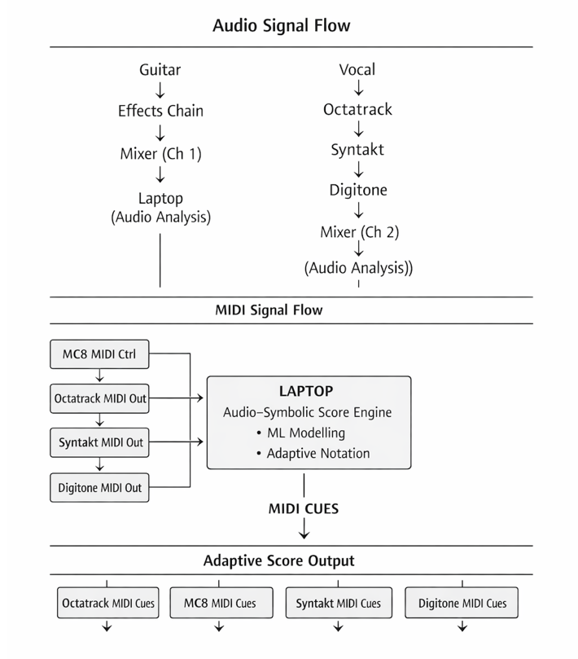
Figure 1. Signal and feedback architecture for the adaptive audio–symbolic scoring system. Audio and MIDI streams are captured, analysed, and used to generate perceptual cues for performers via hardware devices.

The laptop functions as the adaptive engine, performing feature extraction, analysing MIDI and audio events, and generating audio and MIDI cues for the connected devices. This feedback loop demonstrates the emergent, non-visual notation in real time.
  - Software Implementation
The system is implemented in Python as part of the Deep-Improv project [1]. Live audio and MIDI streams are captured and analysed using machine learning models that infer the current state of the performance. These inferences are converted into audio and MIDI cues, which are then routed back to the devices in the setup.
Workshop participants will observe how performer actions influence the adaptive score, and how the score in turn informs performer behaviour, creating a responsive, interactive improvisational environment. Machine learning functions as an adaptive notational layer rather than as a generative agent. Models reshape the conditions under which improvisation unfolds by adjusting cue density, pacing, and timbral emphasis. This establishes a temporal reciprocal feedback loop: performer actions influence the score, and the score modulates performer behaviour. All changes in model state are communicated exclusively through perceptual cues, prioritising listening and embodied interpretation over explicit control or visual feedback.
- performance practice

During the workshop/demo, the vocalist actively manipulates the Electron Octatrack, Syntakt, and Digitone II to shape both vocal processing and the evolving audio score. The guitarist responds to these cues in real time, processing their instrument through a chain of delay, reverb, looping, and other sound manipulation effects.
Both performers listen closely to the same adaptive audio cues, negotiating form, texture, and interaction as the performance unfolds. The absence of visual notation aims to encourage heightened focus and responsiveness, allowing participants to observe how musical structure can emerge organically from listening and interaction [5]. This setup demonstrates how performers can co-construct improvisation through sound, highlighting the interpretive and emergent nature of non-visual notation.
- discussion
This workshop seeks to tangibly illustrate a view of notation as a dynamic, relational process rather than a static artefact. Audio cues function as real-time guidance, transforming listening itself into a form of interpretive literacy.
Participants can directly experience how the system mediates the balance between performer agency and adaptive feedback. The setup also invites reflection on broader questions: how can audio-based cues structure improvisation? What role does psychoacoustics of the particular space play in perceptual guidance? And how can adaptive, non-visual notation support creativity more generally? The approach will offer insight into teaching listening, interaction, and form in music without relying on traditional visual scores.
- conclusion
This workshop will present an adaptive audio–symbolic scoring system in which sound acts as the primary notational medium. Through live guitar and vocal interaction, attendees can observe how symbolic MIDI and live audio streams integrate to create a responsive, non-visual score that constantly changes.
By highlighting the interplay between audio cues, machine learning, and performer interpretation, the workshop will showcase how notation can emerge to become a listening and embodied interaction [7]. MIDI serves as an abstract organisational layer, while audio provides perceptual instruction, expanding current understandings of notation and offering practical insight into interactive, improvisatory music practice.
- references
- J. Gabriel, “Deep-Improv: Adaptive Audio–Symbolic Scoring for Improvised Performance,” GitHub repository, 2025.
- P. Schaeffer, Traité des objets musicaux. Paris, France: Seuil, 1966.
- T. Wishart, On Sonic Art. Amsterdam, Netherlands: Harwood Academic Publishers, 1996.
- C. Roads, Microsound. Cambridge, MA, USA: MIT Press, 2001.
- A. Vickery, “The Limitations of Representing Sound and Notation,” Organised Sound, vol. 19, no. 2, pp. 113–122, 2014.
- G. Assayag and S. Dubnov, “Using Machine Learning to Shape Time-Based Musical Interaction,” Leonardo, vol. 47, no. 1, pp. 45–50, 2014.
- E. Clarke, Ways of Listening: An Ecological Approach to the Perception of Musical Meaning. Oxford, UK: Oxford University Press, 2005.

